Roll No: 2103064

Lab Final
Lab Task Q1
Question: Show circuit diagram and code for 8086 microprocessor which is interfaced with I/O device using 82C55 where 2 push buttons connected to PB0 and PB1 as input, when either button is pressed an LED connected to PC2 should turn off, otherwise it should remain ON.

Solution (Code):
// Roll-2103064
DATA SEGMENT
PORTA EQU 00H
PORTB EQU 02H
PORTC EQU 04H
PORT_CON EQU 06H

DATA ENDS
CODE SEGMENT
MOV AX,DATA
MOV DS,AX

ORG 0000H
START:

MOV DX, PORT_CON
MOV AL,10000000B
OUT DX,AL

JMP XX
XX:

MOV DX,PORTB
IN AL,DX
CMP AL,00000001B
JE OFF
CMP AL,00000010B
JE OFF
JMP ON
ON:
MOV AL,00000100B
MOV DX,PORTC
OUT DX,AL
JMP XX
OFF:
MOV AL,0B
MOV DX,PORTC
OUT DX,AL
JMP XX

CODE ENDS
END

Output (Proteous):
- When no button is pressed.
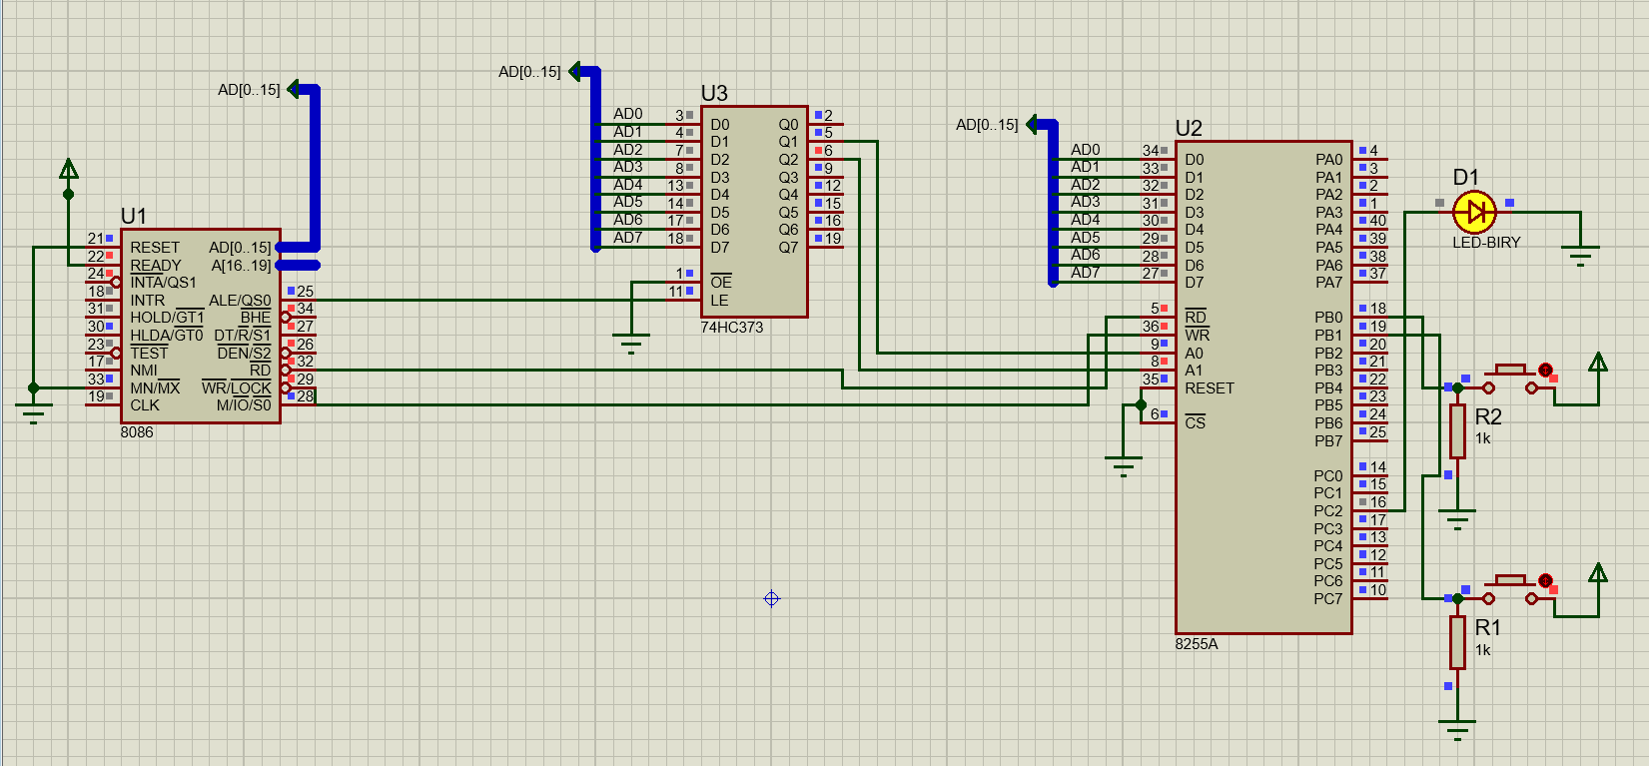

- When button 2 is pressed.
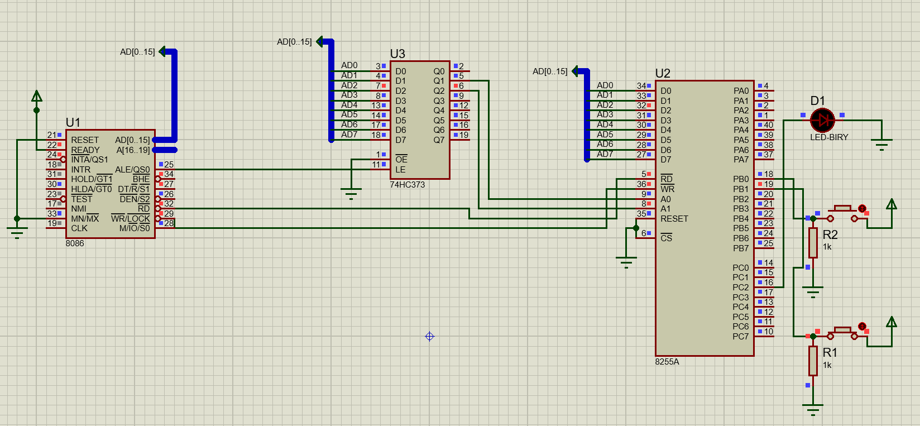

- When button 1 is pressed
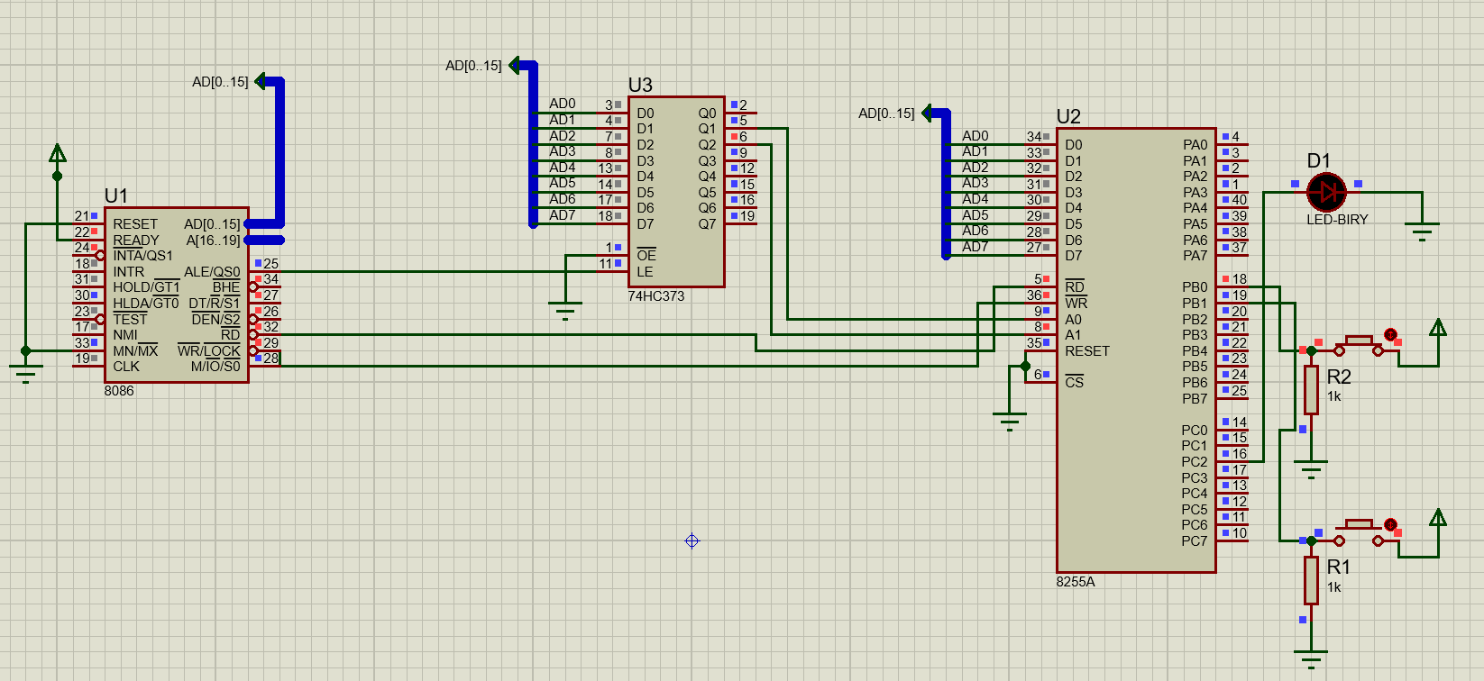

- When both buttons are on:
